A

Mini Project Report

On

**“HOTEL MANAGEMENT SYSTEM”**

Submitted to

**CHHATTISGARH SWAMI VIVEKANAND TECHNICAL UNIVERSITY**

**BHILAI**

in partial fulfillment of the requirement of for the award of degree

Of

**Bachelors of Technology**

In

**COMPUTER SCIENCE AND ENGINEERING**

**By**

**PURVASHA AGRAWAL**

** DEPARTMENT OF COMPUTER SCIENCE AND ENGINEERING**

**SHRI SHANKARACHARYA TECHNICAL CAMPU,**

**JUNWANI, BHILAI(C.G.)**

**SESSION 2021-2022**

CERTIFICATE

This is to certify that the thesis report of the project submitted is an outcome of the project entitled **“hotel management system”** carried out by **PURVASHA AGRAWAL** bearing **Roll no. 310402220146** carried out under my guidance and supervision for the award of Degree in B.Tech in **Computer Science and Engineering** of Chhattisgarh Swami Vivekanand Technical university, Bhilai(C.G.),India.

To the best of my knowledge the report.

(1)Embodies the work of the candidates herself/himself.

(2)Fulfills the requirements of the ordinance relating to the B.Tech Degree of the University.And ,

(3)Is up to the desired standard for the purpose of which is submitted.

Guided by-

PROF.Shankar S Tripathi

Computer Science & Egineering Department

**Shri ShankaraCharya Technical Campus**

**Junwani,Bhilai(C.G.)**

The project work as mentioned above is hereby being recommended and forwarded for examination and evaluation.

**(Signature of Head of Department with seal)**

**ACKNOWLEDGEMENT**

I would like to express my gratitude towards Mr.Shankar Sir for guiding me throughout the project. I also feel thankful and express my kind gratitude towards our class incharge Mrs.Archana Mam for allowing me to conduct Hotel Management system project. The mentioned project was done under the I thank all participants for their positive support and guidance. I feel thankful to the college staff for giving me such a big opportunity. I believe I will enroll in more such events in the coming future. I ensure that this project was done by me and is not copied.

(Signature of student)

**Abstract**

This project aims at creating on Hotel Management System which can be used by Admin and Customers. The admin to advise/publish the availability of rooms in different hotels and customers are checking the availability of room in required hotel. Customers should be able to know the availability of the rooms on a particular date to reserve in hotel. They should be able to reserve the available rooms according to their need in advance to make their stay comfortable. The Admin hands the booking information of customers. The users can register and log into the system. The administrator will know the details of reservation and daily income. The hotel department maintain the seat availability and booking details in certain database. This project provides high security to Admin and user information.

**Hotel Management Project in Python**

This Project on Hotel Management is a general software developed (using Python) to simplify hotel operations by automating them. In this project, “AnCasa” is the project’s hotel name. It covers major aspects of hotel management; it could perform the following operations- Hotel Booking, Provide you with Hotel Rooms Info, Room Service, Billing and Record-Keeping.

**Functions Created**

Home()- Function to display the project’s main screen i.e. the home page of the project or you can say the main menu for selecting the desired operation to perform.

Date(str)- Function to validate date entered by the user/customer.

Booking()- Function for booking room in hotel by entering user/customer details.

Room_Info()- Function to provide users/customers with hotel rooms information(i.e. about room amenities).

Restaurant()- Function for room service which provides user/customer with the restaurant’s menu card to order food at the room.

Payment()- Function for payment of hotel room and restaurant bill generation at the time of check-out.

Record()- Function for keeping records of customers stayed in the hotel.

**System Requirements of the ProjectRecommended System**

RequirementsProcessors:

Intel® Core™ i3 processor 4300M at 2.60 GHz.Disk space: 2 to 4 GB.Operating systems: Windows® 10, MACOS, and UBUNTU.Python Versions: 3.X.X or Higher.Minimum System RequirementsProcessors:

Intel Atom® processor or Intel® Core™ i3 processor.Disk space: 1 GB.Operating systems: Windows 7 or later, MACOS, and UBUNTU.Python Versions: 2.7.X, 3.6.X.Prerequisites before installing MySQL Connector PythonYou need root or administrator privileges to perform the installation process.Python must be installed on your machine.Note: – MySQL Connector Python requires python to be in the system’s PATH. Installation fails if it doesn’t find Python.On Windows, If Python doesn’t exist in the system’s PATH, please manually add the directory containing python.exe yourself.

**INTRODUCTION**

Traditionally, a hotel property management system was defined as a system that enabled a hotel or group of hotels to manage front-office capabilities, such as booking reservations, guest check-in/check-out, room assignment, managing room rates, and billing.

Our Services !

* Online room booking system !
* 24 Hour Restaurant !
* Stay First, Pay After! !
* 24 hours room service !
* Decorated room, properly air-conditioned !
* 24-hour Concierge service !
* Private balcony

**Tools and Technology used**

Hardware (PC) System Requirements:

• Operating System: Windows 2000 or higher with latest updates installed

• Processor: 500MHz or faster

• RAM: 128MB or more

• Video Card: Minimum requirement: 128MB of video memory

• Sound Card: Minimum requirement: 16-bit

➢ Software Requirements

• Sublime Editor

• VS code

• Xampp server

• Web browser.

• PHP

**Working With Project**

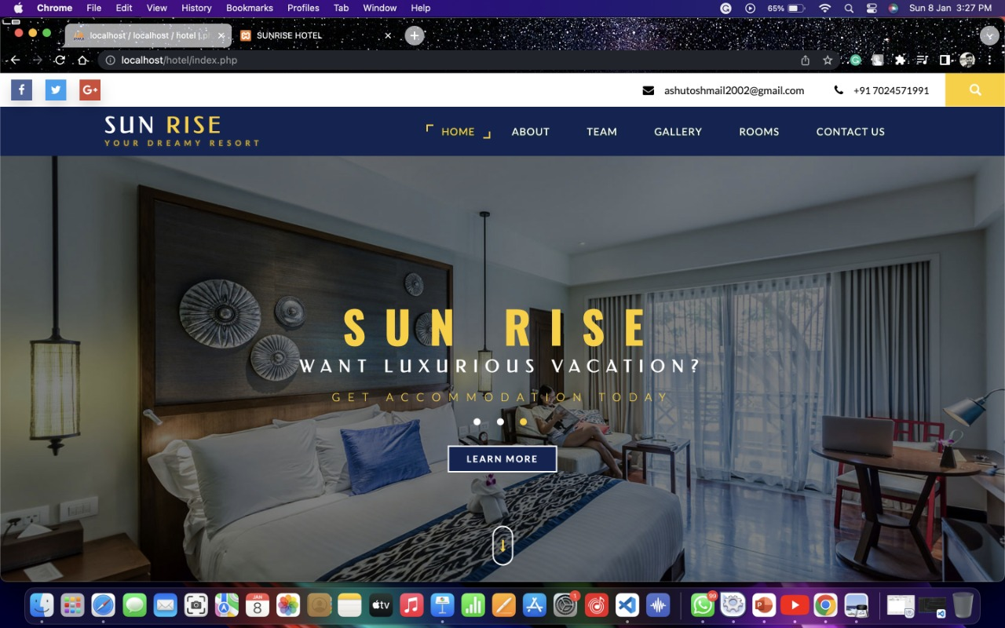

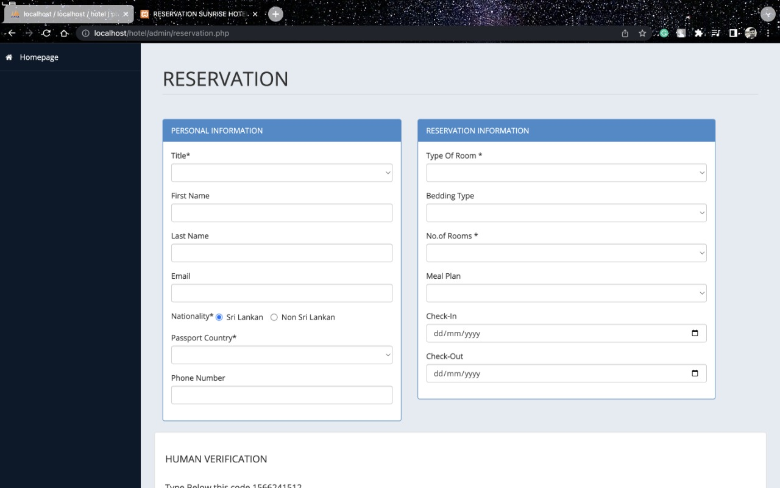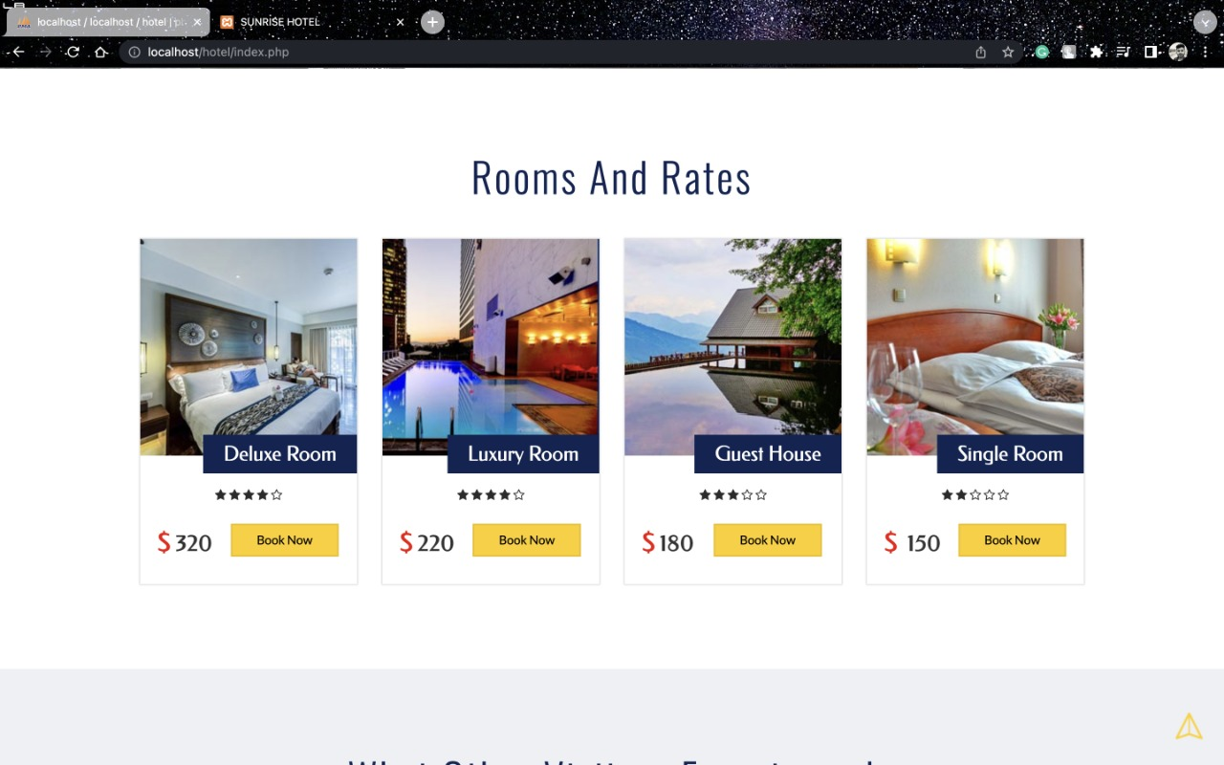

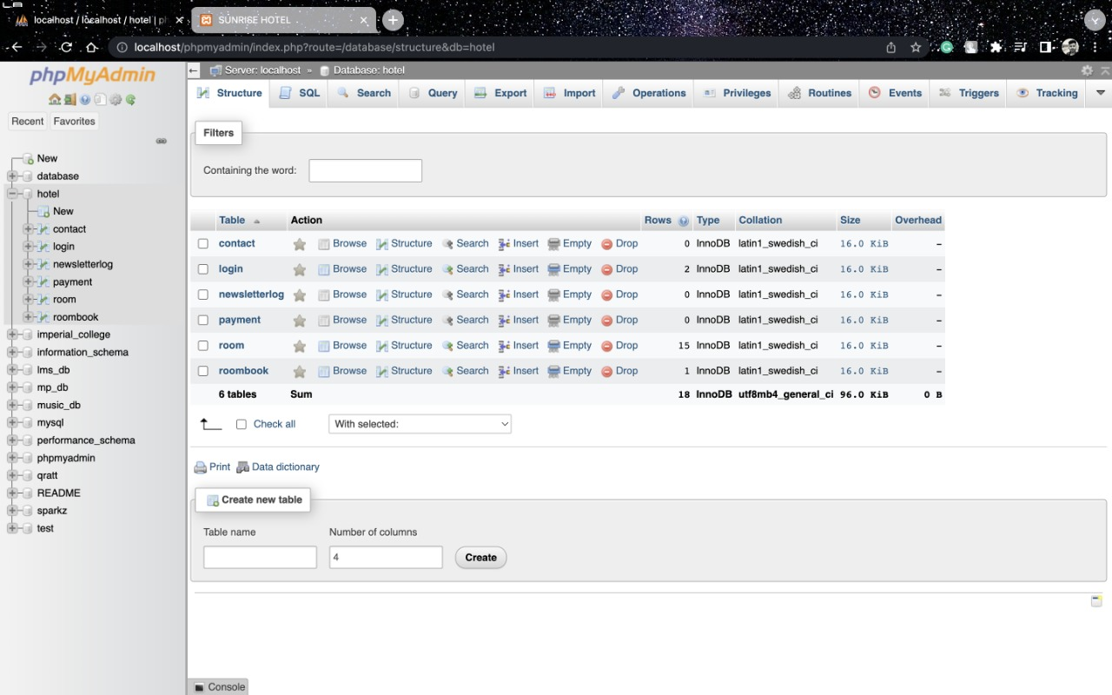

**CONCLUSION AND SCOPE FOR FUTURE WORK**

**! Abstract: The aim of an automated hotel management system is to handle all aspects of the hotel's information and booking system. This application attempted to cover all operations that occur in residential hotels. !**

**Hospitality management software systems are programmed to avoid double bookings and overbookings. Thanks to task automation, they also help prevent errors when front desk staff are inputting important customer data like name, passport details, and card numbers. !**

**Satisfied Employees. ! High Customer Satisfaction**